1

Shadow Walkers Game

SDEV265, Spring 2025

Team Six
2

Table of Contents

- Front page

- Table of contents

- Introduction

- System Requirements

- Installation & Launch

- Basic Controls

- Gameplay Mechanics

- Implementation Details

- Summary

3. Introduction

3

“Shadow Walker” is a purpose-built 2D stealth-avoidance experience that challenges players to master the interplay between light and darkness. Rather than engaging in combat, you must rely on careful timing and spatial awareness to remain undetected by guards whose light beams are lethal on contact. As soon as your character steps into an illuminated area, the run ends—no health bars, no second chances. This document serves as a comprehensive reference for both new and experienced players. You will find clear instructions for installing and launching the game, an in-depth explanation of the control scheme, detailed descriptions of core mechanics, and insights into the underlying implementation. Additionally, you will learn how to navigate the in-game menu—accessing settings, viewing play history, and reviewing your past performances. Use this guide to accelerate your learning curve, refine your stealth tactics, and confidently explore every shadowed corner in pursuit of the highest score.
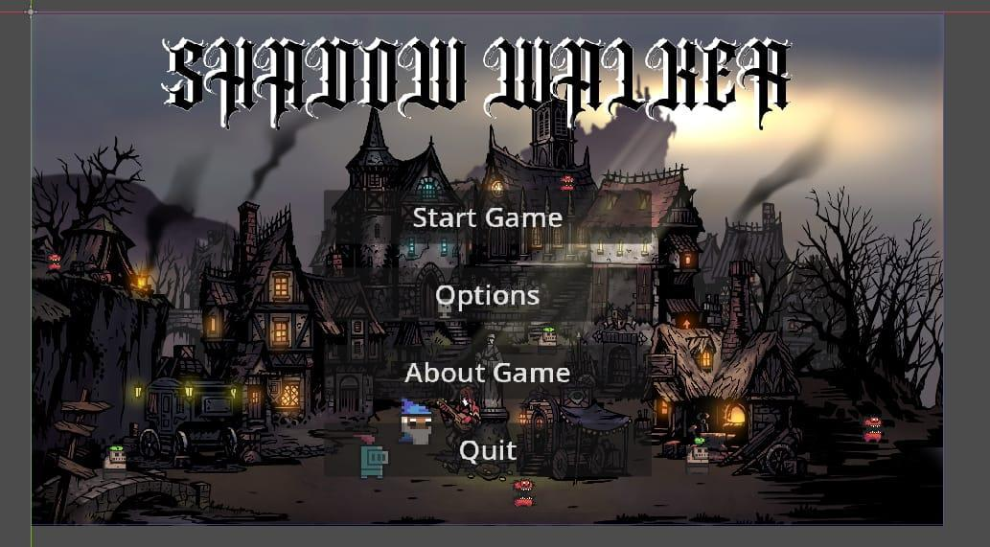

4. System Requirements

4

“Shadow Walker” has been made to run smoothly on modest hardware while scaling gracefully on more powerful systems. The game requires a 64-bit Windows 10 or Windows 11 installation powered by a dual-core 2.0 GHz processor, 2 GB of RAM, and an integrated graphics unit that supports OpenGL 3.3. The total footprint of the game—including all assets and the bundled Godot runtime—is under 200 MB of disk space. Although these baseline specifications will deliver stable performance, we recommend the following for an optimal experience: a quad-core CPU running at 3.0 GHz or higher, 4 GB or more of system memory, and a dedicated GPU with OpenGL 4.x capabilities. A full-HD (1920×1080) display or better will ensure that the game’s minimalist art style and UI elements appear crisp and clear. No additional software dependencies or external libraries are required, as all necessary components are packaged with the game.

5. Installation & Launch

5

Deploying “Shadow Walker” to your Windows PC is a straightforward process that gets you into action within minutes. First, navigate to our GitHub Releases page and download the latest Windows archive, named in the format Shadowwalker_Windows.zip. Once the download completes, right-click the file and select “Extract All…,” choosing a directory such as C:\Games\ShadowWalker. Within the extracted folder, you will find the executable (ShadowWalker.exe), a configuration file (settings.cfg), an assets directory containing graphics and audio, and a concise README. Double-click the executable to launch; if Windows Defender SmartScreen intervenes, click More info and then Run anyway to proceed. On the very first execution, the game will compile and cache shaders, which may introduce a brief pause; subsequent launches will be instantaneous. To adjust graphical parameters, open settings.cfg in Notepad or any text editor, modify resolution or fullscreen flags, save your changes, and relaunch the game. No installer or elevated privileges are necessary. This process may change slightly in the following week, but we'll be in touch, trying to be as precise as possible.

6. Basic Controls

6

The “Shadow Walker” control scheme is minimal, allowing you to concentrate on a stealth strategy rather than complex input sequences. Movement is handled via either the W, A, S, D keys or the arrow keys—pressing a direction key immediately moves the player character one continuous step in that direction. The Esc key opens the pause menu, from which you can resume play, access settings, view “About” information, or quit to the desktop. Upon detection—when your character’s sprite intersects a guard’s light cone—the run terminates and a “Game Over” screen appears. This streamlined input mapping ensures latency-free responsiveness and places a squarely emphasized emphasis on timing and positioning.
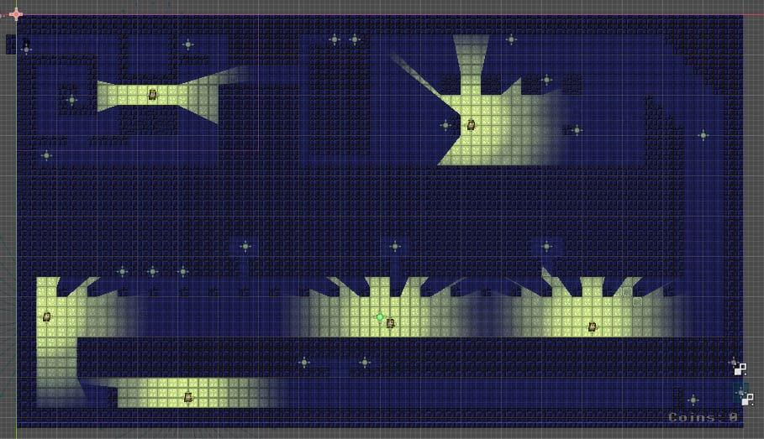

7. Gameplay Mechanics

7

At its core, “Shadow Walker” revolves around the constant tension between safe shadow zones and perilous light beams. Each level comprises a tiled environment with clearly defined dark regions, where you are invisible to the light, and illuminated corridors patrolled by enemies. Guards follow predetermined routes, sweeping their light cones in rhythmic patterns, not pursuing the player beyond their programmed path. Your objective is to collect as many coins as possible—each coin instantly adds up —while timing your movements to slip through gaps in the light. After any run concludes, the “Play History” screen catalogs your score, enabling you to track progress over multiple attempts. This cyclical attempt, analysis, and retry loop underpins the game’s addictive replay value.
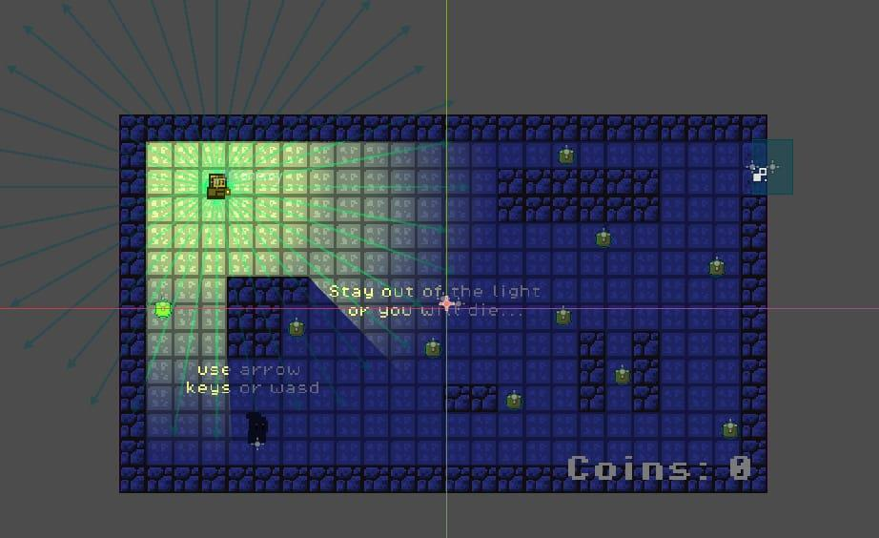

8. Implementation Details

8

“Shadow Walker” is built in Godot 4.x using GDScript, leveraging the engine’s scene tree and physics server for precise collision detection. The ShadowZone component attaches to designated dark-area nodes and updates a boolean isInShadow flag on the player each physics frame. The Guard AI class performs a convex polygon overlap test, representing its vision cone, against the player’s collision shape; if the player is not flagged as “in shadow,” the guard invokes GameManager.triggerGameOver(). Coin instances implement an onCollected() callback that removes the coin node from the scene and calls GameManager.addScore(10). Player locomotion uses Godot’s InputMap API and move_and_slide() to guarantee smooth, frame-rate–independent movement, with a timing function in GameManager. _ process (delta) increments elapsed time and periodically adjusts guard parameters to implement seamless difficulty scaling without discrete level transitions. All UI elements—score display, Game Over screen, and menus—are constructed using Godot’s Control nodes for resolution-independent layout.
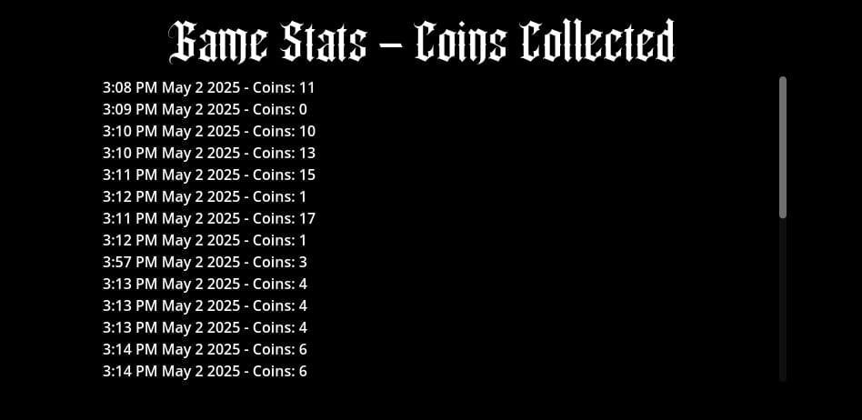
9

c9. Summary

This User Documentation has provided an end-to-end blueprint for installing, configuring, and excelling at “Shadow Walker.” You have learned how to verify system compatibility, deploy the game, master its intuitive control scheme, and understand the stealth-based mechanics that define each run. Behind the scenes, you now appreciate how Godot’s architecture and custom GDScript components collaborate to deliver a responsive, dynamically challenging experience. Armed with these insights, you can refine your shadow-walking tactics, climb the leaderboard through repeated play, and thoroughly enjoy the elegant tension between light and darkness that “Shadow Walker” offers. Good luck— and may your next run be your best yet.
